**Issue: Addressing the rights of women in Afghanistan following the establishment of Taliban rule**

**Geographic Context:**

Afghanistan is a landlocked nation located in central Asia on the Iranian plateau, bordering with Pakistan to the east and Iran to the west. Lying on important trade routes, such as the silk road, and connecting the nations of the Middle East and Europe to Eastern Asia and Southern Asia, it has been, for millennia, sought out by great empires and armies, traces of which can still be found all over the country today. It is characterised by its geographical features such as jagged peaks covered in snow year-round and vast empty deserts. These features have separated the nation into 4 distinct regions, all with Politics, culture, and language within each region often differ from that which influences the central government in the capital city of Kabul, instead they are more similar to neighbouring countries.[1]

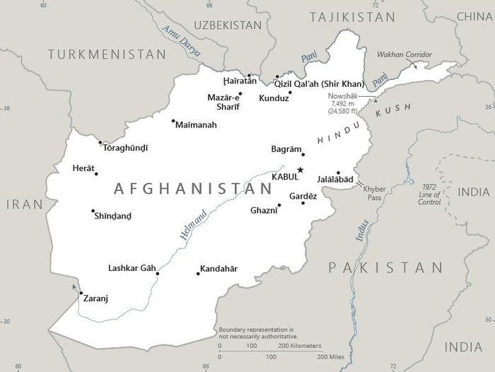

The nation of Afghanistan is home to 34,940,837 people, with many different ethnicities, such as the Pashtun (the main ethnicity in the nation), Tajiks and Hazara to name a few. all these ethnicities have different customs, culture, languages, etc…[2]

The capital of the nation of Afghanistan is Kabul, the largest urban centre in the nation and also the country’s economic and political centre. A settlement has existed at or near Kabul for some 3,500 years, but it was not until the early 20th century that the city extended north of the Kabul River. This growth continued through the 1980s, when villagers from areas affected by the Afghan War migrated to the relative safety of Kabul. The city has witnessed unprecedented growth since the U.S.-led invasion of the country in 2001 in response to the September 11 attacks.[3]

The main religion in Afghanistan is Islam, with 99.7% of the population being in a sect of Islam (mainly Sunni Islam but also Shia Islam). There are also some very small groups of other faiths, including Christians, Sikhs, Hindus and Baha’i. However, the numbers of minority Muslim and non-Muslim groups have significantly declined over the past decades as people have fled sectarian tensions and conflict.[4]

**Historical Background:**

Afghanistan’s land has a long, complex history of foreign domination and internal conflict among rival factions. During 1919-1921, after winning the Third British Afghan War, Afghanistan gained independence.[5] Amir Amanullah Khan (r. 1919-1929) launched major socio-economic reforms to modernise the country, including those that liberated women from their conventional cultural norms and roles. By 1926, he declared Afghanistan a monarchy and named himself king. His wife, Queen Soraya Tarzi**,** one of the world's early feminist leaders, received praise for defying convention and dressing in western attire outside the royal palace.

However, this wasn’t accepted by many local administrations and regional tribes as it goes against the doctrines of Islam. Opposition to his reforms forced his abdication in 1929. King Muhammid Nadir Shah soon came to power. Nadir Shah swiftly overthrew the majority of Amanullah's reforms and supported men's historic dominance in Afghanistan. Afghan women's decade of social, economic, and political advancement and independence were quickly undone.[6] Nevertheless, during his four years of reign, he saw numerous uprisings and rebellions. Eventually, he was assassinated in the Royal Palace.[7]

Stability returned in 1933 with Muhammid Zahir Shah’s ascent to the throne, the former king’s descendent. He ruled Afghanistan for 40 years and brought relative peace and stability to the nation. He continued to introduce progressive reforms aimed at modernising the nation’s economy, infrastructure, and women’s rights, including: legislation supporting women's education, workforce participation, and political empowerment. However, regional powers’ backlash and disregard to the laws resulted in Afghanistan's persistence of female subjugation.

On 16 July, 1973 Zahir Shah’s cousin, Mohammad Daoud Khan, with the assistance of Soviet Committee for State Security (KGB) officers, Parcham leader Babrak Karmal, and communist Afghan military officers carried out a coup which overthrew the constitutional monarchy and declared Afghanistan a republic.[8] He became the first President in Afghanistan and looked to the Soviet Union for military and economic support. In addition, he proposes certain social reforms, such as giving women more rights and greater visibility in public.[9] However, he approached in a cautious manner. Despite trying to not irritate his public opposition, he still managed to gain women the right to appear unveiled in public, with Kubra Noorzai becoming the first female government minister, women elected to parliament, and significant advancements in female education, employment, and representation in both government and top private sector roles.

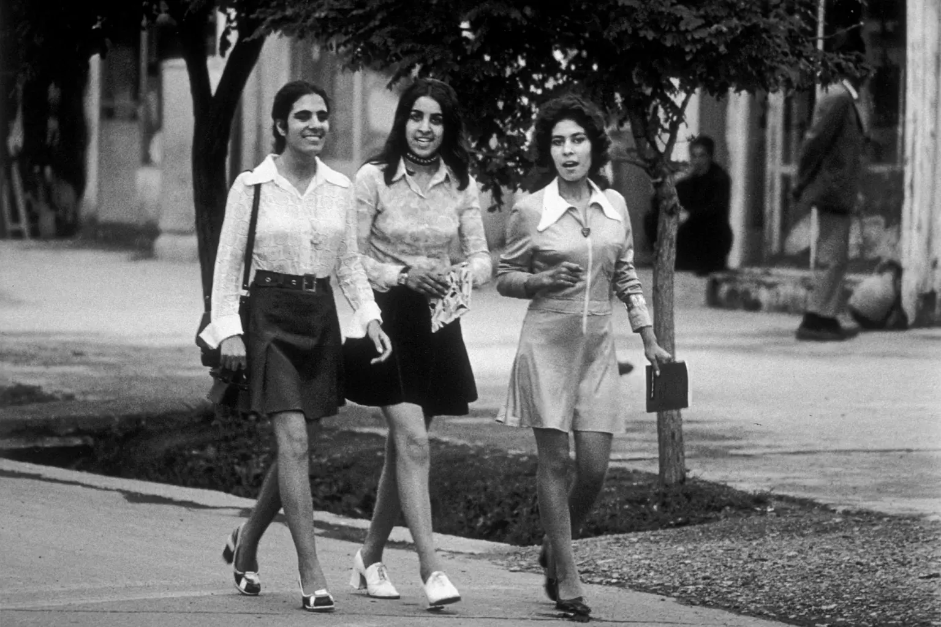

1970s Afghanistan saw striking scenes of women in mini skirts, symbolising social liberation.[10]

The relationship between the Soviet Union and Mohammad Daoud was good in the start. In 1974, the two nations established a joint economic commission. However, by 1975, Daoud had established his own party, the National Revolutionary Party. He began to lower the dependency of Afghanistan on the Soviet Union and repair relations with Pakistan, Iran and the United States. Leonid Brezhnev, the Soviet leader, wanted Afghanistan to get rid of outside experts from the United Nation, NATO, and international, mostly western, influences. However, Mohammad Daoud responded: “Afghanistan shall remain poor, if necessary, but free in its acts and decisions”.[11] Soviet leaders acted. In 1978, the USSR invaded Afghanistan, and the communist People’s Democratic Party of Afghanistan (PDPA) [overthrew Daoud Khan](https://www.history.com/this-day-in-history/afghan-president-is-overthrown-and-murdered) in what became known as the Saur Revolution.[12]

The government of PDPA sought to abolish feudal practices like bride price and forced marriage, raised the minimum marriage age, and promoted education for both men and women through widespread literacy programs. However, many Afghans, especially in rural areas, did not embrace these reforms, as before.[13] Furthermore, the United States, Pakistan, Iran, and Saudi Arabia intervened by providing billions in equipment, weapons, and aid to support the Mujahideen insurgents in resisting the spread of communism and Soviet influence in Afghanistan. Ultimately, in mid-1987, due to multiple factors, including problems within the Soviet Union, Soviet leader Mikhail Gorbachev announced the start of a full military withdrawal from Afghanistan.[14] Nevertheless, lacking a central power structure, various Mujahideen groups and other guerrilla fighters vied for power.

During all these wars, women in Afghanistan were often brutalized, with some treated as war spoils and subjected to rape by armed guards, reportedly as both intimidation and a “reward” for soldiers. In a harrowing case from March 1994, a 15-year-old girl in Kabul’s Chel Sotton described: “They shot my father right in front of me. He was a shop-keeper. It was nine o’clock at night. They came to our house and told him they had orders to kill him because he allowed me to go to school. The Mujahideen had already stopped me from going to school, but that was not enough. They then came and killed my father. I cannot describe what they did to me after killing my father…”.

At the end of 1994, a new political regime, the Taliban, emerged. They promised to rid Afghanistan of corrupt Mujahideen groups, and to some extent they did. But for Afghanistan's population, and necessary for Afghan women, their strict interpretation of Sharia law fundamentally violated their rights, disrespecting the UN charter and other international laws. Whilst some degree of order was established in certain parts of the country, and their actions were supported by some traditional Afghan families, this order would be brought along with torture, execution, religious intolerance, and a slew of other atrocities.[15]

Under the Taliban regime, women faced severe oppression, confined to their homes behind closed doors and painted windows, forbidden from leaving without a burqa. Girls were denied education and could only receive medical care if a female doctor was available. Violations of these restrictions were punished harshly, ranging “from whipping to public stoning”. In a war-torn country where nearly half the population had suffered death, injury, or displacement, many widows and women without male providers were left with desperate choices, including forced prostitution or sending their children to dangerous work just to survive.

Nearly all educational opportunities for females were closed, except those solely focused on teaching the Qur’an. As a result, Afghanistan now in 2024 still has a female literacy rate of 22.6%, one of the lowest in the world.[16] In response, women activists and the Revolutionary Association of the Women of Afghanistan (RAWA) set up secret schools in private homes. According to one RAWA member, "our teachers have to give secret lessons in people's homes. We'll have a copy of the Koran on the table, and if the Taliban arrive, we immediately hide the textbooks. That way, we can say we're studying the Koran." Operating underground to avoid beatings or worse, RAWA educators frequently change locations to protect their students and themselves.[17]

Following the 9/11 terrorist attacks, the United States, joined by Britain, invaded Afghanistan and initiated a bombing campaign against Taliban forces, effectively achieving military victory. The United States made efforts to improve the status of Afghan women by building schools and advocating for their rights. However, despite legal protections for education, anti-government organisations continued to threaten and attack women seeking education and public participation, undermining the progress made and leaving many in precarious situations. Nonetheless, the Taliban maintained a presence in the region and, after the withdrawal of American forces in August 2021,[18] regained control of the country.[19]

**Recent development:**

Recently, the restrictions on the rights of women in Afghanistan have grown even more restrictive since the Taliban have taken over the nation. Today women can't do many things we all take for granted and use on a daily basis without their husband or a mahram (a man that they can not marry, such as a father or brother). This includes going to a hospital, opening a business or simply showing their face in public.[20]

**Past UN resolutions:**

1. <https://www.un.org/womenwatch/daw/csw/afgresd.htm>
2. ​​<https://www.securitycouncilreport.org/atf/cf/%7B65BFCF9B-6D27-4E9C-8CD3-CF6E4FF96FF9%7D/N2312149.pdf>
3. <https://documents.un.org/doc/undoc/gen/n00/720/18/pdf/n0072018.pdf>
4. <https://www.unwomen.org/sites/default/files/Headquarters/Attachments/Sections/CSW/PFA_E_Final_WEB.pdf>
5. <https://documents.un.org/doc/undoc/gen/n13/523/44/pdf/n1352344.pdf>
6. <https://documents.un.org/doc/undoc/gen/n19/339/37/pdf/n1933937.pdf>

**Focus of Debate:**

The UN Security Council's debate on the rights of women in Afghanistan under Taliban rule would focus on safeguarding their fundamental freedoms and ensuring access to education, healthcare, and employment. The discussion would emphasise the importance of delivering humanitarian aid that prioritises women’s needs and establishing reliable monitoring systems to report on the status of their rights. The council would address practical measures for maintaining these services despite restrictive conditions, aiming to prevent further erosion of the gains made in previous decades. However, consideration should also be given to the Taliban’s interpretation of religious principles and how these impact women's rights.

Additionally, the council would deliberate on coordinated international responses to influence the Taliban's policies through diplomatic engagement, sanctions, or incentives. Members would explore partnerships with regional actors to maximise pressure and advocate for adherence to international human rights standards. The goal would be to balance immediate interventions with long-term strategies that promote the empowerment and protection of Afghan women, ensuring that they remain a focal point of global humanitarian and political efforts.

**Bloc Positions:**

The United States of America:

The U.S.A places significant emphasis on the protection of women's rights in Afghanistan, viewing this as part of its broader human rights and democratic values agenda. At the same time, it also has interests and wants to spread influence in the nation due to its crucial geopolitical location. Following its military involvement post-9/11, the U.S. seeks to influence the Taliban through diplomacy, sanctions, and international coalitions. By engaging with allies and international organisations, the U.S. aims to maintain humanitarian assistance for Afghan women while balancing assertive measures with dialogue to promote progress in women's rights.

The United Kingdom:

The U.K. remains committed to advocating for the rights of women in Afghanistan, reflecting its historical role in NATO operations during the conflict. The nation employs diplomatic engagement and collaborates with international bodies to deliver aid while promoting compliance with human rights standards. Its strategy prioritises humanitarian support to empower women by providing essential services and ensuring their basic human rights.

Pakistan:

Pakistan's approach to women's rights in Afghanistan is shaped by its historical and cultural ties to the region. It emphasises dialogue and non-interference, advocating for Afghanistan's sovereignty while seeking mutual stability. As a predominantly Muslim nation, Pakistan considers the cultural context of women's rights, recognizing the need to respect local traditions while advocating for improvements. Its focus remains on cooperation with regional partners and global powers to promote stability and development initiatives that enhance women's well-being.

People’s Republic of China:

China is increasingly vocal about women’s rights in Afghanistan, recognizing their importance for achieving social stability and economic development. As it engages with the Taliban, China emphasises the need to improve women's access to education, healthcare, and employment, viewing these rights as essential for fostering a stable society. By supporting development projects and humanitarian initiatives, China aims to create conditions that empower women while aligning with its broader strategic interests in the region. This approach reflects China’s commitment to promoting social progress as a means of enhancing its influence in Afghanistan and ensuring long-term stability.

The Russian Federation:

Russia actively promotes women's rights in Afghanistan as part of its broader commitment to human rights and regional stability. Understanding that women's empowerment is critical to sustainable development, Russia advocates for initiatives that improve access to education, healthcare, and economic opportunities for women. Furthermore, the promotion of equality aligns with core values of communism, reinforcing Russia's stance on gender equity as a shared principle. Through diplomatic engagement with the Taliban and collaboration with international partners, Russia seeks to foster an environment where women's rights are respected and prioritised.

**Helpful articles to read:**

<https://www.britannica.com/place/Kabul>

<https://tsosrefugees.org/featured-issues/afghanistan/geography-and-politics>

<https://www.britannica.com/place/Kabul>

<https://culturalatlas.sbs.com.au/afghan-culture/afghan-culture-religion>

​​<https://en.wikipedia.org/wiki/Afghan_Independence_Day>

<https://www.iyops.org/post/the-great-tribulations-of-women-in-afghanistan>

<https://www.unofficialroyalty.com/assassination-of-mohammed-nadir-shah-king-of-afghanistan-1933/>

Casey W. Ralston, *The Alexandrian V, no. 1* (2016)

<https://www.pbs.org/newshour/politics/asia-jan-june11-timeline-afghanistan>

<https://nypost.com/2021/09/11/incredible-scenes-of-womens-liberation-in-1970s-afghanistan/>

<https://www.airuniversity.af.edu/Wild-Blue-Yonder/Articles/Article-Display/Article/2072075/afghanistan-intelligence-war/#sdendnote14sym>

<https://www.history.com/news/1979-soviet-invasion-afghanistan>

<https://www.amnesty.org/en/wp-content/uploads/2021/06/asa110111999en.pdf>

<https://en.wikipedia.org/wiki/Soviet%E2%80%93Afghan_War>

<https://www.iyops.org/post/the-great-tribulations-of-women-in-afghanistan>

<https://worldpopulationreview.com/country-rankings/literacy-rate-by-country>

<https://scholarship.law.wm.edu/cgi/viewcontent.cgi?article=1135&context=wmjowl>

<https://foreignaffairs.house.gov/getting-answers-on-afghanistan-withdrawal/>

<https://www.pewresearch.org/short-reads/2022/08/17/a-year-later-a-look-back-at-public-opinion-about-the-u-s-military-exit-from-afghanistan/>

<https://www.usip.org/tracking-talibans-Mistreatment-women>

1. <https://www.britannica.com/place/Kabul>
2. <https://tsosrefugees.org/featured-issues/afghanistan/geography-and-politics>
3. <https://www.britannica.com/place/Kabul>
4. <https://culturalatlas.sbs.com.au/afghan-culture/afghan-culture-religion>
5. ​​<https://en.wikipedia.org/wiki/Afghan_Independence_Day>
6. <https://www.iyops.org/post/the-great-tribulations-of-women-in-afghanistan>
7. <https://www.unofficialroyalty.com/assassination-of-mohammed-nadir-shah-king-of-afghanistan-1933/>
8. Casey W. Ralston, *The Alexandrian V, no. 1* (2016)
9. <https://www.pbs.org/newshour/politics/asia-jan-june11-timeline-afghanistan>
10. <https://nypost.com/2021/09/11/incredible-scenes-of-womens-liberation-in-1970s-afghanistan/>
11. <https://www.airuniversity.af.edu/Wild-Blue-Yonder/Articles/Article-Display/Article/2072075/afghanistan-intelligence-war/#sdendnote14sym>
12. <https://www.history.com/news/1979-soviet-invasion-afghanistan>
13. <https://www.amnesty.org/en/wp-content/uploads/2021/06/asa110111999en.pdf>
14. <https://en.wikipedia.org/wiki/Soviet%E2%80%93Afghan_War>
15. <https://www.iyops.org/post/the-great-tribulations-of-women-in-afghanistan>
16. <https://worldpopulationreview.com/country-rankings/literacy-rate-by-country>
17. <https://scholarship.law.wm.edu/cgi/viewcontent.cgi?article=1135&context=wmjowl>
18. <https://foreignaffairs.house.gov/getting-answers-on-afghanistan-withdrawal/>
19. <https://www.pewresearch.org/short-reads/2022/08/17/a-year-later-a-look-back-at-public-opinion-about-the-u-s-military-exit-from-afghanistan/>
20. <https://www.usip.org/tracking-talibans-Mistreatment-women>